

Stonelow Junior School

School Information Report for Children with Special Educational Needs

All Dronfield schools have a similar approach to meeting the needs of pupils with Special Educational Needs and are supported by the Local Authority to ensure that all pupils, regardless of their specific needs, make the best possible progress in school. All schools are supported to be as inclusive as possible, with the needs of pupils with a Special Educational Need(s) and or disabilities being met in a mainstream setting wherever possible, where families want this to happen.

What is ‘Special Educational Needs’ (SEN) or a ‘Disability’?

‘A child or young person has special educational needs if he or she has a learning difficulty or disability which calls for special educational provision to be made for him or her. A learning difficulty or disability is a significantly greater difficulty in learning than the majority of others of the same age. Special educational provision means educational or training provision that is additional to, or different from, that made generally for others of the same age in a mainstream setting in England.’
(Special Educational Needs Code of Practice, 2015)

The SEND Code of Practice clearly states that, where possible, children and young people should attend mainstream schools in their local area and should be encouraged to feel part of their local community.
The four areas of need identified in the SEND code of practice are:
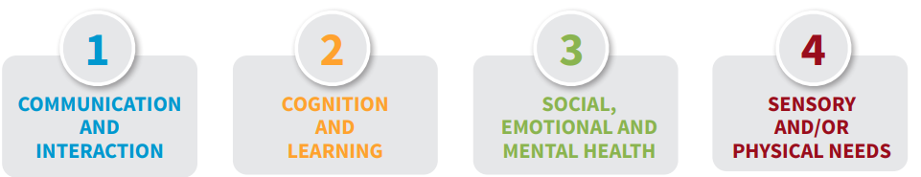

Stonelow Junior School follows the Derbyshire Graduated Response for SEND. This document can be found on the Local Offer. It offers guidance on how the needs of SEND pupils can be appropriately met.
The graduated response starts with a whole school approach to Inclusion. Below is outlined what our school can offer to pupils with SEND needs.

- PEOPLE WHO SUPPORT CHILDREN WITH SPECIAL EDUCATIONAL NEEDS/ AND OR DISABILITIES IN THIS SCHOOL

School based information | People | Summary of responsibilities
Who are the best people to talk to in this school about my child’s difficulties with learning/ Special Educational Needs/Disability (SEND)?  And how can I talk to them about my child if I need to? | Class Teacher in the first instance.  The SENDCO (Special Educational Needs coordinator)  Mrs Liz Kent available on: 01246 414370  Elizabeth.kent@dronfieldstonelow.derbyshire.sch.uk  Teaching Assistants (TA)  Head teacher(s)  (Catherine Byard)  (Jennifer Nabipour)  SEND Governor  (Vanessa Siddall) | ALL teachers are teachers of SEND. As per the SEND Policy, the class teacher is responsible for:  - Ensuring that all children have access to good/outstanding teaching and that the curriculum is adapted to meet your child’s individual needs (also known as differentiation). This is referred to as Quality First Teaching (QFT) and is the first step of the Graduated Response.  - Checking on the progress of your child and identifying, planning and delivering any additional help your child may need (this could be things like targeted work, additional support, adapting resources etc..) and discussing amendments with the Special Educational Needs Co-ordinator (SENDCO) as necessary.  - Ensuring that all members of staff working with your child in school are aware of your child’s individual needs and/or conditions and what specific adjustments need to be made to enable them to be included and make progress.  - Ensuring that all staff working with your child in school are supported in delivering the planned work/programme for your child, so they can achieve the best possible progress. This may involve the use of additional adults, outside specialist help and specially planned work and resources.  - Ensuring that the school’s SEND Policy is followed in their classroom and for all the pupils they teach with any SEND.  She is responsible for:  - Coordinating all the support for children with special educational needs (SEN) and or disabilities, and developing the school’s SEND Policy to make sure all children get a consistent, high-quality response to meeting their needs in school.  - Ensuring that you are:  - involved in supporting your child’s learning  - kept informed about the support your child is getting  - involved in reviewing how they are doing  - part of planning ahead for them.  The SENDco will:  liaise with all the other people who may be coming into school to help support your child’s learning. At Stonelow, when necessary, we liaise with:  - The ISAS team (Inclusion Support Advisory Service)  - Educational Psychology  - Support Service for visual, physical and hearing impairments  - Speech and Language Therapy  - Occupational Therapy  - Community Paediatrics  - Clinical Paediatrics  The SENDco will utilise these services to:  - provide available specialist support for teachers and support staff in the school so they can help your child (and other pupils with SEN and/or disabilities in the school) to achieve their potential.  - support your child’s class teacher to ensure any individual learning programmes (ILP) are appropriately planned and delivered.  - organise training for staff so they are aware and confident about how to meet the needs of your child and others within our school.  A teaching & learning assistant may be allocated to support pupils with exceptional special educational needs and/or disabilities and whilst they take a very valuable role in your child’s education, we would prefer that questions regarding your child’s learning and progress are directed in the first instance to the staff members named above.  Of course, as a school we welcome daily dialogue between parents and TAs on how a child’s day has been and we do actively encourage this continued feedback.  He/ She is responsible for:  - The day -to-day management of all aspects of the school, this includes the support for children with SEN and/or disabilities. He/ She will give responsibility to the Sendco and class teachers but is still responsible for ensuring that your child’s needs are met.  - He/ She must make sure that the Governing Body is kept up to date about any issues in the school relating to SEND.  He/ She is responsible for:  - Making sure that the school has an up to date SEND Policy.  - Making sure that the school has appropriate provision and has made necessary adaptations to meet the needs of all children in the school.  - Making sure that the necessary support is made for any child who attends the school who has SEN and/or disabilities.  - Making visits to understand and monitor the support given to children with SEND in the school and being part of the process to ensure your child achieves his/her potential in school.

- HOW COULD MY CHILD GET HELP IN SCHOOL?

We follow the Derbyshire Graduated Response for SEND here at Stonelow. Two areas of support are identified.

 | Types of support provided -also showing the stage of the Code of Practice children will be at when receiving this input. | What would this mean for your child? | Who can get this kind of support?
What are the different types of support available for children with SEN and /or disabilities in this school? | - Class teacher input via high quality classroom teaching. (QFT)  Support is about making ‘reasonable adjustments’ and doing things a bit differently.  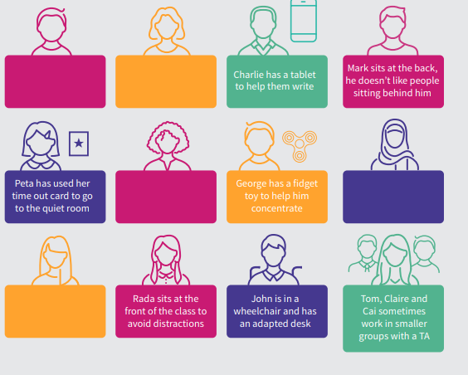 | - The teacher will have the highest possible expectations for your child and all pupils in their class via QFT. Support is about making ‘reasonable adjustments’ and doing things a bit differently.  - All teaching is based on building on what your child already knows, can do and can understand.  - Putting in place different ways of teaching so that your child is fully involved in learning in class. This may involve things like using more practical learning or providing different resources adapted for your child.  - Putting in place specific strategies (which may be suggested by the sendco or staff from outside agencies) to enable your child to access the learning task. | All children in school receive this.  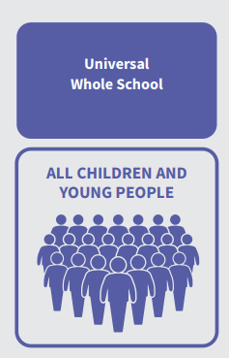
 | - SEND Support  SEND Support includes the following:  - Specific small group work. This group may be:  - Run in the classroom or outside the room.  - Run by a teacher or (most often) a Teaching Assistant who has had training to run these groups.  These are often called Intervention groups by schools | - Your child’s teacher will have carefully checked on your child’s progress and will have decided that your child has gaps in their understanding/learning and needs some extra support to close the gap between your child and their peers.  - He/ She will plan group sessions for your child with targets to help your child to make more progress.  - A Teaching assistant/teacher (or outside professional (like a Speech and Language Therapist)) will run these small group sessions using the teacher’s plans, or a recommended programme. | Any child who has specific gaps in their understanding of a subject/area of learning.  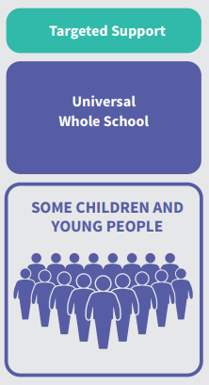
 | 3) Targeted and/or specialist groups run by outside agencies e.g. Speech and Language therapy or Occupational Therapy groups.  AND/OR Individual support  This means they have been identified by the class teacher/SENDCO as needing some extra specialist support in school from a professional outside the school. This may be from:  - Local Authority central services such as the ASD Outreach Team or Sensory Service (for students with a hearing or visual need)  - Outside agencies such as the Speech and Language therapy (SALT) Service.  - ISAT (Inclusion Support Advisory Teacher) | - If your child has been identified as needing more specialist input instead of or in addition to good and outstanding class room teaching and intervention groups, referrals will be made to outside agencies to advise and support the school in enabling your child to make progress.  - Before referrals are made you will be asked to come to a meeting to discuss your child’s progress and help plan possible ways forward.  - If it is agreed that the support of an outside agency is a way forward, you will be asked to give your permission for the school to refer your child to a specialist professional e.g. a Speech and Language Therapist or Educational Psychologist. This will help the school and yourself understand your child’s particular needs better.  - The specialist professional will work with your child to understand their needs and make recommendations, which may include:  -Making changes to the way your child is supported in class e.g. some individual support or changing some aspects of teaching to support them better  -Support to set targets which will include their specific professional expertise  -Your child’s involvement in a group run by school staff under the guidance of the outside professional e.g a social skills group or sensory circuit  -A group or individual work with outside professional  - The school may suggest that your child needs some agreed individual support or group support in school. They will tell you how the support will be used and what strategies will be put in place. | Children with specific barriers to learning that cannot be overcome through whole class high quality teaching and intervention groups.
 | - Specified Individual support for your child.  This is usually provided via either INCLUSION PANEL funding or an EHCP (Education, Health and Care Plan) This means your child will have been identified by the class teacher/SENDCO as needing a particularly high level of individual and small group teaching which cannot be provided from the resources already delegated to the school.  Usually, if your child requires this high level of support they may also need specialist support in school from a professional outside the school. This may be from:  - ISAS team (Inclusion Support Advisory Service)  - Outside agencies such as the Speech and Language therapy (SALT) Service, Occupational therapy service, Physiotherapy and/or CAMHS | - The school (or you) can request that the Local Authority carry out a statutory assessment of your child’s needs. This is a legal process and you can find more details about this in the Local Authority (LA) based Local Offer, on the Derbyshire web site:  - After the school have sent in the request to the Local Authority (with a lot of information about your child, including some from you), they will then decide whether they think your child’s needs (as described in the paperwork provided), seem complex enough to need a statutory assessment. If this is the case, they will ask you and all professionals involved with your child to write a report outlining your child’s needs. (If they do not think your child needs this, they will ask the school to continue with the support at the relevant level of the SEN code of practice or recommend the use IPF.)  After the reports have all been sent in the Local Authority will decide if your child’s needs are severe, complex and lifelong and that they need further extra and additional support in school to make good progress. If this is the case, they will write an EHC Plan. If this is not the case, they will ask the school to continue with the SEN support at its current level and also set up a meeting in school to ensure a plan is in place to ensure your child makes as much progress as possible. Inclusion Panel funding may be advised.  - The EHC Plan will outline needs. It may refer to the number of hours of individual/small group support your child may receive from the LA and how the support should be used/what strategies should be put in place. It will also have long and short-term goals for your child.  - Additional adults may be used to support your child with whole class learning, run individual programmes or small groups including your child. | Children whose learning needs are:  - Severe, complex and lifelong  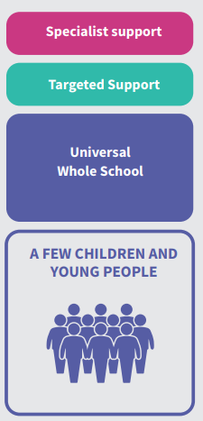  And  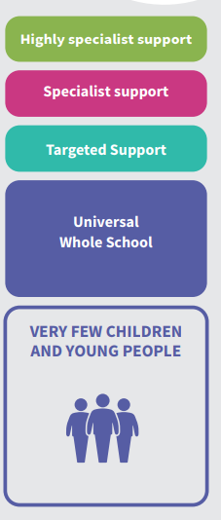
How will you support my child with identified special needs when starting school? | - We will first invite you to visit the school with your child to have a look around and speak to staff.  - If other professionals are involved, a Team Around Family (TAF) meeting or similar, may be held to discuss your child’s needs, share strategies used, and ensure provision is put in place before your child starts.  - We may suggest adaptations to the settling in period to help your child to settle more easily.  - If applicable, visits by staff to your child’s previous setting may be made to facilitate a successful transition.
How can I let the school know I am concerned about my child’s progress in school? | - If you have concerns about your child’s progress you should speak to your child’s class teacher initially.  - If you are not happy that the concerns are being managed and that your child is still not making progress you should speak to the SENDCO or Head teacher.  - If you still have concerns, you can speak to the school SEND Governor.
How will the school let me know if they have any concerns about my child’s learning in school? | - When a teacher or a parent has raised concerns about your child’s progress, and targeted teaching has not met the child’s needs, the teacher will raise this with the SENDCO and may complete an Initial Concerns Sheet.  - Schools also have meetings every term between each class teacher and a senior staff member in the school to ensure all children are making good progress. This is another way your child may be identified as not making as much progress as expected.  - If your child is then identified as not making expected progress the school will make a decision about whether to monitor this or set up an intervention group and will inform you.  - If your child is still not making expected progress the school will discuss with you:  - any concerns you may have  - any further interventions or referrals to outside professionals to support your child’s learning  - how school and home can work together, to support your child.
How is extra support allocated to children and how do they move between the different levels? | - The school budget, received from Derbyshire LA, includes some money for supporting children with SEN.  - The Headteacher decides on the budget for Special Educational Needs in consultation with the school governors, on the basis of the needs of the children currently in the school.  - The Head teacher and the SENDCO discuss all the information they have about SEN in the school, including:  - the children getting extra support already  - the children needing extra support  - the children who have been identified as not making as much progress as would be expected.  They then decide what resources/training and support is needed.  - All resources/training and support are reviewed regularly and changes made as needed.

How are the adults in school helped to work with children with a SEND and what training do they have? | - The SENDCO’s job is to support the class teachers in planning for children with SEN.  - The school has a school development plan, including identified training needs for all staff to improve the teaching and learning of children including those with SEND. This may include whole school training on SEND issues or to support identified groups of learners in school, such as Autism and dyslexia.  - Whole staff training to disseminate knowledge, strategies and experience, to ensure consistency of the school’s approach for children with a SEND.  - Individual teachers and support staff attend training courses run by outside agencies that are relevant to the needs of specific children in their class e.g from ISAS team or medical /health training to support staff in implementing care plans.  Training takes place on a regular basis. If you would like to hear about the training which is currently taking place or has taken place by the staff members in the school, please speak to the Headteacher or SENDCO.
How will we measure the progress of your child in school? And how will I know about this? | 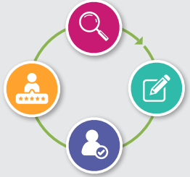  - Your child’s progress is continually monitored by his/her class teacher. This will be carried out by a process of ASSSESS, PLAN, DO, REVIEW  - His/her progress is reviewed formally every term and a National Curriculum level or equivalent given in Reading, Writing, Maths as well as progress in other areas, as appropriate, such as attendance, engagement in learning and behaviour.  - At the end of key stage 2 (year 6) all children are required to be formally assessed using Standard Assessment Tests (SATS). This is something the government requires all schools to do and are the results that are published nationally.  - The progress of children with an EHC Plan is formally reviewed at an Annual Review with all adults involved with the child’s education.  - The progress of children receiving GRIP funding will be reviewed annually with all adults involved in the child’s education to assess whether the funding and provision should continue.  - A range of ways will be used to keep you informed, which may include:  - Home/school book  - Letters/certificates sent home  - Additional meetings as required  - Reports
What support do we have for you as a parent of child with an SEN/and or disabilities? | - We would like you to talk to your child’s class teacher regularly so we know what they are doing at home and we can tell you about what we are doing in school. This is to ensure that we are doing similar things to support them both at home and school and can share what is working in both places. Parent evenings take place regularly throughout the year where any Individual Learning Plans (ILPs) can be shared.  - The school’s Family Support Worker (Mrs Shona Hardcastle) is available to advise and support where necessary if needs extend beyond SEND. Contact to be made via the school office.  - All information from outside professionals will be discussed with you with the person involved directly, or where this is not possible, in a report. The SENDCO will also arrange to meet with you to discuss any new assessments and ideas suggested by outside agencies for your child.  - Homework will be adjusted as needed to your child’s individual needs.  - A home/school contact book may be used to support communication with you, when this has been agreed to be useful for you and your child.  In addition: If you child is undergoing an EHCP assessment, you will also be supported by the school and Local Authority. They will ensure that you fully understand the process.
How have we made this school physically accessible to children with SEND? | - The school is as accessible as it can be, given that it is built on 3 levels, to children with physical disability. There are ramps and a toilet with disabled access. The LA have some limited resources for providing adaptations necessary should pupils with physical disabilities be admitted. There is also an accessibility plan.  - We ensure that equipment used is accessible to all children regardless of their needs.

How will we support your child when they are leaving this school? OR moving on to another class? | We recognise that ‘moving on’ can be difficult for a child with SEN/and or disabilities and take steps to ensure that any transition is a smooth as possible.  - If your child is moving to another school:  - We will contact the new school’s SENDCO and ensure he/she knows about any special arrangements or support that need to be made for your child.  - We will make sure that all records about your child are passed on as soon as possible.  - When moving classes in school:  - Information will be passed on to the new class teacher IN ADVANCE and in most cases, a planning meeting will take place with the new teacher.  - In Year 6  - The SENDCO and/or class teacher will liaise with to discuss the specific needs of your child with the SENDCO of their secondary school.  - Where possible your child will visit their new school on several occasions and in some cases staff from the new school will visit your child in this school.

GLOSSARY OF TERMS
SEN | Special Educational Needs
SEND | Special Educational Needs and or disabilities
SENDCO | Special Educational Needs & Disability Coordinator
SEN Code of Practice | The legal document that sets out the requirements for SEN
EHC plan | Education, Health, Care Plan
SALT | Speech and Language Therapist
CAMHS | Child & Adolescent Mental Health Service
EP | Educational Psychologist
IPF | Inclusion Panel Funding
ISAS & ISAT | Inclusion Support Advisory Service/Teacher

